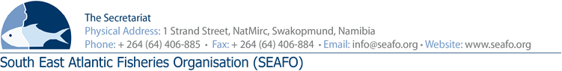
PROVISIONAL AGENDA FOR THE 15TH ANNUAL MEETING OF THE COMMISSIOM (COM) - 2018

CHAIR: Mr. V Gomes (ANGOLA) Venue: Strand Hotel, Swakopmund
VICE-AIR: Mr. L. Molledo (EU) Date: 26, 29 & 30 November 2018

 | Agenda Item | Working Document
1 | Opening of the Meeting
2 | Appointment of Rapporteur
3 | Adoption of the Agenda and Meeting Arrangements | DOC/COM/00/2018  DOC/COM/01/2018  DOC/COM/02/2018
4 | Introduction and Admission of Observers
5 | Opening Statements by Contracting Parties and Observers
6 | Status of the Convention in Respect of Membership
7 | Extension of the SEAFO Convention Area
8 | Renumbering of Conservation Measures | DOC/COM/03/2018
9 | Future Biennial Meetings | DOC/COM/04/2018
10 | Presentation of 2018 Scientific Committee Rapport | DOC/COM/05/2018
11 | Presentation of 2018 Compliance Committee Rapport | DOC/COM/06/2018
12 | Presentation of 2018 Standing Committee on Administration and Finance Rapport | DOC/COM/07/2018
13 | Reports of meetings attended by the Secretariat | DOC/COM/08/2018  DOC/COM/09/2018  DOC/COM/10/2018  DOC/COM/11/2018
14 | Reports of SEAFO Representatives at 2018 meetings of other Organizations | DOC/COM/12/2017  DOC/COM/13/2017  DOC/COM/14/2017  DOC/COM/15/2017
15 | Nominations of Parties to represent SEAFO at 2019 meetings of other Organizations
16 | Any other Matters
17 | Election of New Chair and Vice-Chair
18 | Venue and Date of the next Commission meeting
19 | Closure of the Meeting

Circulation Date: 26 October 2018 SEAFO Website

